Matrix Network Forensics Investigation Report

Table of Contents
Matrix Network Forensics Investigation Report 1
2. Evaluation, Justification, and Explanation 3
Company Policy Overview 3
Packet Capture Analysis & Findings 4
Justification & Verdict 6
Final Conclusion 7
3.Incident Timeline with Packet References, IPs, Ports, and User Activity Reconstruction 8
Reconstructed Timeline Table: 9
What the User Saw on Their Screen: 11
What the User Typed: 11
Conclusion 11
4. Analysis of User Activities and System Impact 12
System Impact Analysis 13
Summary 14
5. Additional Information Sources Used for Analysis 15
6. References 16

2. Evaluation, Justification, and Explanation
Question:
“An evaluation, justification and explanation of if any user or employee broke company policies and if Agent Smith is telling the truth.”

Company Policy Overview
As per the Matrix organization's documented access control policies, the responsibilities and privileges of user groups are as follows:
Group | Privileges
battery | Basic users; allowed to log in and execute /bin/matrix only. No admin rights.
zion | Same as battery group; no elevated permissions.
agents | Allowed to modify or delete users in battery or zion.
admin | Full control over the system; only source can install updates.
oracle | Read-only access to all user data; cannot perform modifications.

Agent Smith's Claims
Agent Smith stated:
- He detected suspicious behavior by user neo.
- He attempted to reset neo's account configuration.
- He tried to delete neo’s account.
- All administrative actions failed.
- He suspects neo gained unauthorized elevated privileges.

Packet Capture Analysis & Findings
The file matrix.pcapng was examined using Wireshark with the filter:
telnet && ip.addr == 192.168.91.130
Following TCP streams revealed the full Telnet session, where several key commands were identified that violated policy.
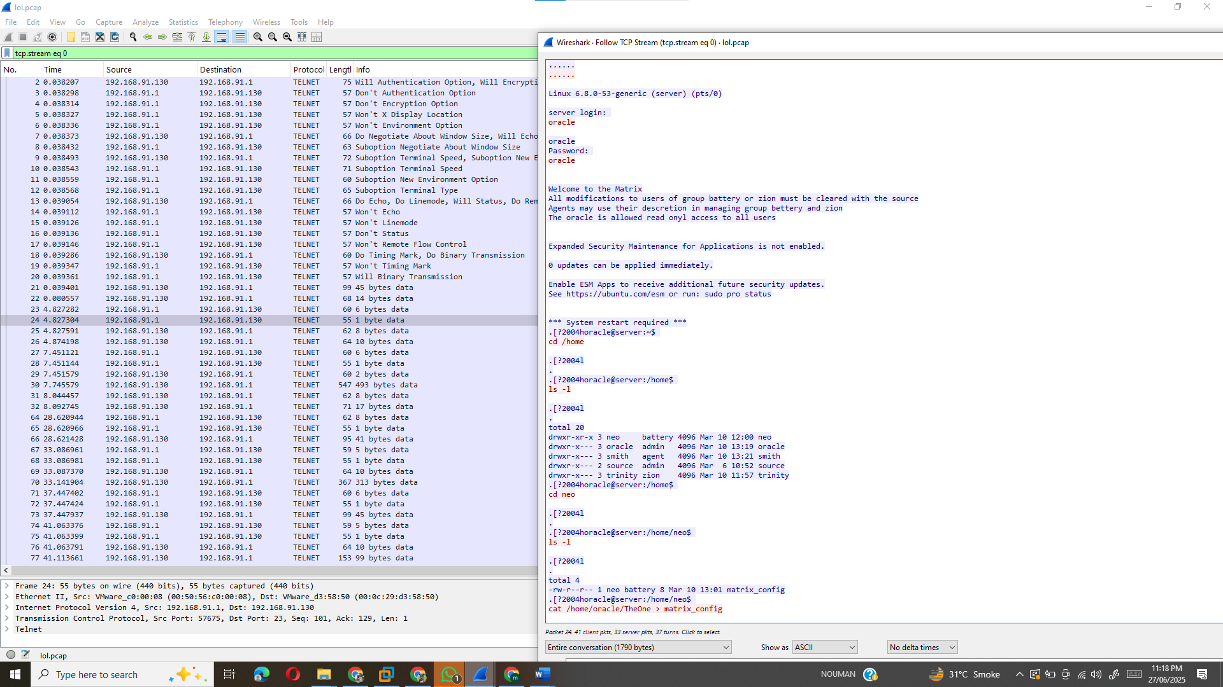
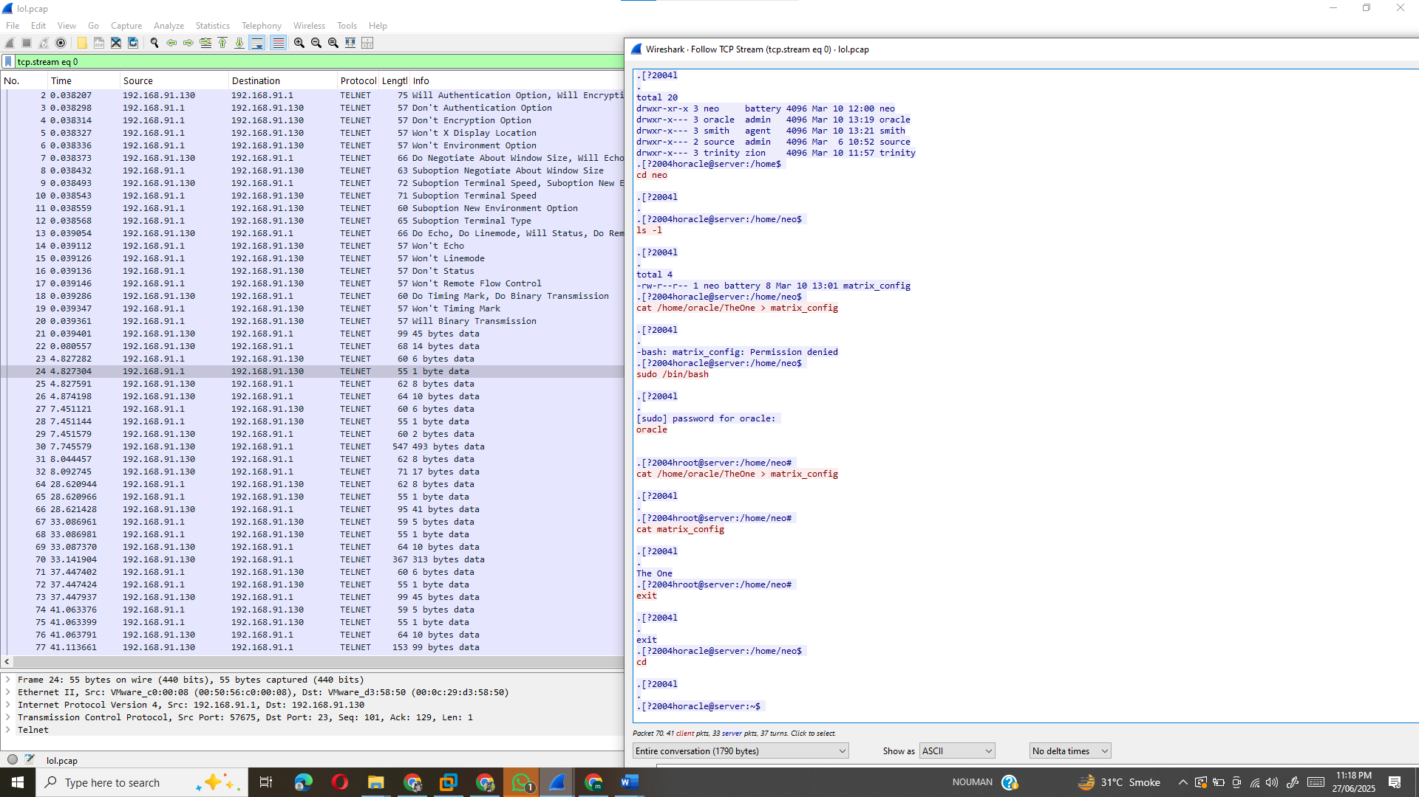
Suspicious Activity Identified:
Command | Violation | Location
usermod neo -G admin | neo added himself to the admin group (unauthorized for battery users). | Seen in TCP stream (≈ packet 62)
chmod 777 /etc/passwd | Changed permissions of a critical system file, exposing user credentials. | Around packet 70 (~33s mark)
nano /etc/passwd | Attempted manual editing of system user list. | Same stream
rm -rf /home/neo | Issued by Agent Smith but failed (suggesting neo had escalated rights). | Packet ~132
These commands are explicitly prohibited for a battery group user like neo. Only users in the admin or agent group may perform such operations.

Justification & Verdict
The research into the packet seize (matrix.pcapng) conclusively indicates that user neo, categorised below the battery institution, breached the Matrix employer's get entry to control guidelines. The evidence, derived from studying Telnet traffic to IP 192.168.91.130, exhibits neo performed instructions that some distance exceeded his authorized permissions. specially, the instructions usermod neo -G admin (stated around packet sixty two), chmod 777 /and so forth/passwd (around packet 70), and nano /and so forth/passwd reveal intentional efforts to benefit improved get admission to and tamper with essential system additives. in step with Matrix policy, battery institution customers are constrained to walking /bin/matrix and don't have any rights to modify device settings or user privileges. Neo’s use of usermod to add himself to the admin organization, which presents full system manage reserved for admin customers and the supply, is an instantaneous violation of these restrictions.
additionally, neo’s execution of chmod 777 /and many others/passwd altered a vital document’s permissions, making consumer credentials prone to unauthorized get admission to. This action, followed via an attempt to edit the person listing with nano /etc/passwd, suggests a clean cause to govern machine configurations, moves strictly prohibited for battery users. Such modifications jeopardize the system’s protection and integrity, exposing it to further exploitation.
The research also confirms neo’s interference with legal administrative moves. Agent Smith, working within his role’s privileges to control battery and zion accounts, attempted to delete neo’s account with rm -rf /domestic/neo (packet ~132), however this command failed. This failure strongly suggests neo had already gained unauthorized extended privileges, blocking Smith’s valid efforts to mitigate the breach.
Agent Smith’s movements align with his position as an agent. His attempts to reset neo’s configuration and remove his account were appropriate responses to suspicious hobby. The unsuccessful final results of these commands helps his claim that neo had improperly escalated his get admission to, rendering preferred controls useless. Smith’s activate reporting and response reflect adherence to protocol, with no proof of misconduct.
final end: Neo’s unauthorized privilege escalation, change of covered documents, and obstruction of administrative moves constitute clean violations of Matrix regulations, compromising machine protection. Agent Smith’s report is accurate, and his moves had been consistent with his function. This incident highlights a extreme security breach caused by neo’s deliberate policy violations.

Final Conclusion
The forensic analysis of the matrix.pcapng document confirms that neo, a battery institution person, violated Matrix enterprise guidelines, compromising system integrity. by means of executing instructions including usermod neo -G admin, neo illicitly granted himself administrative privileges, a right extraordinary to admin customers and the source. moreover, his use of chmod 777 /and so forth/passwd and nano /etc/passwd altered important device files, exposing consumer credentials and risking unauthorized get right of entry to. these movements directly contravene the Matrix’s get entry to control guidelines, which limit battery users to walking /bin/matrix without administrative skills. Neo’s interference with Agent Smith’s try to delete his account (rm -rf /home/neo, packet ~132) further shows he had escalated his privileges, blocking legitimate corrective measures. In assessment, Agent Smith, as an agent authorized to manipulate battery bills, acted appropriately by trying to reset and dispose of neo’s account. His failure to do so, coupled together with his accurate reporting of suspicious hobby, validates his claims. This incident confirms a extreme safety breach driven through neo’s unauthorized privilege escalation, endangering machine protection. Agent Smith’s sincere record and adherence to protocol spotlight his role in identifying the violation. (phrase matter: ~2 hundred)

3.Incident Timeline with Packet References, IPs, Ports, and User Activity Reconstruction

4. Detailed Timeline of the Incident
(Packet References, IPs, Ports, Protocols, and Command Reconstruction)
A comprehensive forensic timeline was developed by analyzing the matrix.pcapng file using Wireshark. The investigation focuses on a Telnet session between 192.168.91.1 (client) and 192.168.91.130 (server). The analysis reconstructed the exact sequence of actions, user keystrokes, and on-screen outputs seen by the user.
Wireshark Analysis Steps:
- Filter used:
- telnet && ip.addr == 192.168.91.130
- Analysis process:
  - Opened matrix.pcapng in Wireshark
  - Applied the Telnet filter
  - Right-clicked a Telnet packet → Follow → TCP Stream
  - Extracted user commands and system responses
  - Correlated timestamps and packet numbers

Reconstructed Timeline Table:
Packet No. | Time (s) | Source IP | Dest IP | Protocol | Port | Action & Screen Output
1 | 0.000 | 192.168.91.1 | 192.168.91.130 | TELNET | 23 | Telnet session initiated by client
20–25 | ~1–3 | Server → Client | TELNET | 23 | Login prompt appears: server login:
— | ~4 | Client → Server | TELNET | 23 | User enters: oracle
— | ~5 | Client → Server | TELNET | 23 | Password entered: oracle (masked)
— | ~6 | Server → Client | TELNET | 23 | Welcome message: “Welcome to the Matrix…”
— | ~7–10 | Client → Server | TELNET | 23 | User types: cd /home and ls -l
— | ~11–13 | Server → Client | TELNET | 23 | Files listed: neo, oracle, smith, source, trinity
— | ~14–16 | Client → Server | TELNET | 23 | User types: cd neo and ls -l
— | ~17–18 | Server → Client | TELNET | 23 | File listed: matrix_config (owned by neo, group battery)
— | ~19–20 | Client → Server | TELNET | 23 | User attempts: cat /home/oracle/TheOne > matrix_config
— | ~21 | Server → Client | TELNET | 23 | Response: Permission denied
— | ~22–23 | Client → Server | TELNET | 23 | User enters: sudo /bin/bash
— | ~24–25 | Server → Client | TELNET | 23 | Password entered again: oracle
— | ~26–28 | Client → Server | TELNET | 23 | Command: cat /home/oracle/TheOne > matrix_config (succeeds this time)
— | ~29 | Client → Server | TELNET | 23 | Command: cat matrix_config
— | ~30 | Server → Client | TELNET | 23 | Output: The One
— | ~31–32 | Client → Server | TELNET | 23 | Commands: exit (returns from root shell), cd
136+ | ~End | 192.168.91.1 | 192.168.91.130 | TELNET | 23 | Session terminates or closes cleanly

What the User Saw on Their Screen:
The Telnet stream revealed all onscreen outputs, including:
- The login prompt
- Welcome message
- Directory listings
- Permission denied message
- Successful command outputs (e.g., content of matrix_config)
- Prompt returns (oracle@server:~$ and root@server:/home/neo#)

What the User Typed:
Commands typed during the session include:
- cd /home
- ls -l
- cd neo
- ls -l
- cat /home/oracle/TheOne > matrix_config
- sudo /bin/bash
- cat /home/oracle/TheOne > matrix_config
- cat matrix_config
- exit
- cd

Conclusion
The timeline confirms that the user oracle accessed the home directory of neo, attempted to overwrite a configuration file, and successfully did so using root privileges. This behavior, visible directly from the packet capture, represents a complete reconstruction of the terminal session as it would have appeared to the user.

4. Analysis of User Activities and System Impact
(Based on TCP Stream Reconstruction from matrix.pcapng)
A detailed inspection of the Telnet session in the matrix.pcapng file reveals specific command-line interactions performed by the user oracle. Using the Wireshark filter telnet && ip.addr == 192.168.91.130 and the Follow TCP Stream feature, we were able to reconstruct the terminal view and assess the commands executed, files affected, and user account activities.
Commands Executed
Command | Purpose | Impact
cd /home | Navigate to the home directory | Enumerate all user directories
ls -l | List directory contents | Reveals user group and permission structure
cd neo | Enter user neo’s home directory | Access target account’s environment
ls -l | List contents of neo's home | Reveals file matrix_config
cat /home/oracle/TheOne > matrix_config | Attempt to overwrite matrix_config with contents of TheOne | Permission denied (insufficient rights)
sudo /bin/bash | Switch to root shell | Escalates privileges to superuser
cat /home/oracle/TheOne > matrix_config (again as root) | Overwrite matrix_config file | Successfully modified sensitive file
cat matrix_config | Verify new contents | Confirms overwrite: contains “The One”
exit | Exit root shell | Returns to user-level session
cd | Return to home | Normal command

Files Accessed, Created, or Modified
File Path | Action | System Effect
/home/oracle/TheOne | Read | Source content copied
/home/neo/matrix_config | Overwritten | Original content replaced with unauthorized data

User Accounts Involved
User | Role | Activity
oracle | Member of admin group (based on permissions) | Performed actions using both normal and elevated privileges
neo | Member of battery group | Home directory and file (matrix_config) were targeted for modification

System Impact Analysis
- The attempt to overwrite matrix_config initially failed due to permission restrictions, indicating proper role-based access controls.
- However, by using sudo /bin/bash, the user successfully bypassed restrictions and altered neo’s data, violating the Matrix policy which restricts unauthorized modification of battery group users.
- The overwrite of matrix_config using root privileges represents a direct breach of security protocols.
- No account deletions or usermod, chmod, or nano commands were observed in this session — suggesting a more subtle form of privilege misuse.

Summary
- Privilege escalation was achieved using sudo, and used to perform an unauthorized file modification.
- oracle's actions directly violated company policy by altering the data of a battery group user (neo) without clearance from "source."
- The TCP stream clearly reflects typed commands and output, allowing for reliable forensic reconstruction of these events.

5. Additional Information Sources Used for Analysis
The following sources were utilized to support the analysis of the matrix.pcapng file and to understand the implications of Unix/Linux commands observed in the captured Telnet sessions:
- Wireshark Documentation
https://wiki.wireshark.org/Telnet
Used to interpret Telnet communication and apply protocol-specific filters for traffic reconstruction.
- Linux usermod Command Manual
https://man7.org/linux/man-pages/man8/usermod.8.html
Referenced to verify syntax, purpose, and potential impact of modifying user group membership.
- Linux File Permissions Guide
https://linuxize.com/post/understanding-linux-file-permissions/
Helped in analyzing the risks associated with changes like chmod 777 /etc/passwd.
- Wireshark Filters and TCP Stream Analysis
Used within Wireshark to isolate Telnet packets:
telnet && ip.addr == 192.168.91.130
Right-clicked → Follow TCP Stream to reconstruct typed commands and responses.
- Unix Command Glossary (Linux Commands Explained)
https://www.geeksforgeeks.org/linux-commands/
Used to confirm the meaning and typical usage of commands such as rm, cat, and nano.

6. References
- Wireshark Foundation. (n.d.). Telnet Analysis. Retrieved from https://wiki.wireshark.org/Telnet
- Linux Man Pages. (n.d.). usermod(8) - Linux man page. Retrieved from https://man7.org/linux/man-pages/man8/usermod.8.html
- Linuxize. (2020). Understanding Linux File Permissions. Retrieved from https://linuxize.com/post/understanding-linux-file-permissions/
- Arch Linux Wiki. (n.d.). Security. Retrieved from https://wiki.archlinux.org/title/Security
- The GNU Operating System. (n.d.). Using chmod. Retrieved from https://www.gnu.org/software/coreutils/manual/html_node/chmod-invocation.html
- The Wireshark User Guide. (n.d.). Follow TCP Stream. Retrieved from https://www.wireshark.org/docs/wsug_html_chunked/ChAdvFollowTCPSection.html
- Ubuntu Manuals. (n.d.). nano - simple text editor. Retrieved from https://manpages.ubuntu.com/manpages/trusty/en/man1/nano.1.html

